**Name: Saif Alam**

**Roll No. 61**

**ITW Practical 1**

**Aim: Overview of MATLAB**

**Overview:**

MATLAB, short for "MATrix LABoratory," is a powerful and versatile programming language and environment primarily used for numerical computing and data analysis. Developed by MathWorks, MATLAB has gained widespread popularity in academia, industry, and research due to its extensive range of features and applications. This report provides an overview of MATLAB, including its history, key features, applications, and advantages.

**History:**

* MATLAB was first created by Cleve Moler in the late 1970s as a tool for his students to have easy access to LINPACK and EISPACK libraries.
* In the early 1980s, MATLAB was rewritten in C and commercially released by MathWorks in 1984.
* Over the years, MATLAB has seen numerous updates and enhancements, becoming a dominant tool in fields such as engineering, physics, finance, and more.

**Features:**

1. Interactive Environment: MATLAB offers an interactive environment that allows users to execute commands, perform calculations, and visualize results immediately.
2. Matrix-Based Operations: MATLAB is renowned for its matrix-based approach to computation. It treats data as matrices, simplifying many mathematical operations.
3. Extensive Functionality: The software includes a vast library of built-in functions for a variety of tasks, from linear algebra to signal processing to machine learning.
4. Plotting and Visualization: MATLAB provides comprehensive tools for creating 2D and 3D plots, graphs, and visualizations, aiding in the exploration and representation of data.
5. Data Analysis: MATLAB facilitates data manipulation, transformation, and statistical analysis, making it valuable for extracting insights from raw data.

**Applications:**

1. Engineering: MATLAB is extensively used in engineering disciplines for tasks such as system design, control systems analysis, signal processing, and image analysis.
2. Science: Scientists use MATLAB for data analysis, modelling physical phenomena, and simulating scientific experiments.
3. Mathematics: MATLAB's numerical capabilities make it valuable in solving complex mathematical problems and equations.
4. Finance: Financial analysts utilize MATLAB for quantitative analysis, risk assessment, and algorithmic trading strategies.
5. Machine Learning: MATLAB offers machine-learning tools for data pre-processing, feature extraction, model training, and evaluation.
6. Research: MATLAB serves as a powerful platform for researchers across disciplines, aiding in data exploration, experimentation, and result visualization.

**Output:**

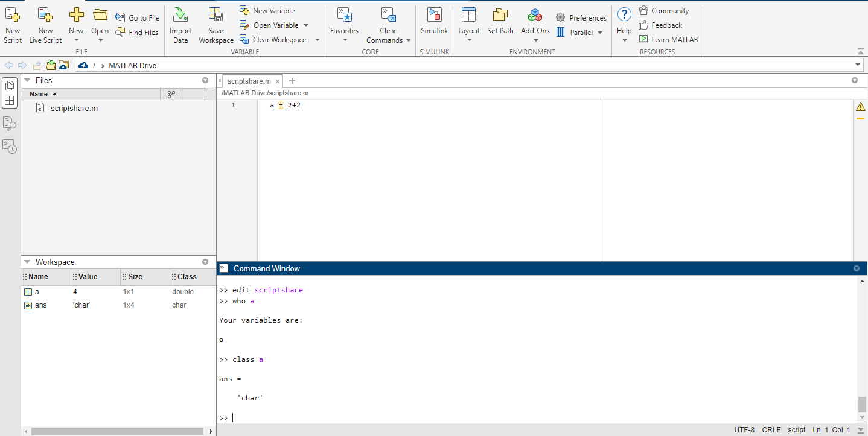

**Conclusion**: MATLAB has transformed the way professionals approach numerical computation, data analysis, and algorithm development. Its versatility, rich features, and interactive environment make it a favoured choice in various industries and research fields. As technology evolves, MATLAB continues to adapt and expand its capabilities, ensuring its relevance in solving complex problems and advancing innovation.